Biocair sponsors TTC And Leie sports club in Belgium
Biocair, the global life science logistics specialist, recently announced its new sponsorship of Flanders-based table tennis sports club, TTC and Leie. The club’s 160 members compete in both the Belgian national and regional leagues, as well as participating in international tournaments.
As part of the sponsorship Biocair is supporting the Multimove project, a pioneering exercise program designed to encourage exercise among young children aged between 3-8 years old. Focusing on developing motor skills, the program is led by a team of certified trainers and combines a variety of different sports with the aim of developing 12 fundamental movements. These are all basic skills that a child should acquire at a young age to stimulate and promote motor development, and include movements such as climbing, catching and jumping. The Multimove project was first developed in a study by the Universities of Ghent, Brussels and Leuven in Belgium.
Didier Vanden Abeele, General Manager for Biocair Belgium, comments “With Biocair being based in Belgium, it’s great to see the company actively supporting the local communities in which it operates. I see first-hand the benefits Multimove brings to the young children beyond the scientific and motor development, such as skills gained from learning to work together as a team and developing new friends.”

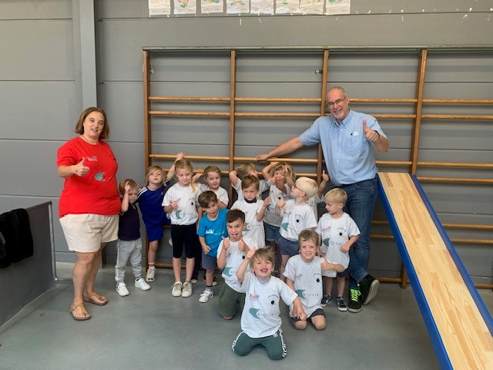
Multimove participants, featuring Biocair’s Didier Vanden Abeele (far right)

ENDS

About Biocair
Since 1986, Biocair has established a global reputation as a leading GDP logistics specialist within the pharmaceutical, biotechnology and life sciences sectors. Biocair has built up a unique, client-centric approach by employing scientists in front-line logistics positions and assembling a team of best-in-class industry experts in quality, cold chain and regulatory compliance. Biocair focuses on providing the most comprehensive time-sensitive and temperature-controlled logistics services available whilst delivering flexible, tailored, cost-effective solutions to all its clients. It is committed to delivering complete end-to-end logistics solutions through its 24/7 operation and global network spanning across Europe, Africa, Asia and the Americas.
Biocair employs over 550 people worldwide and provides specialist logistics services to more than 160 countries through a global network of partners. Biocair’s offices are located in the UK, France, Belgium, Germany, USA, South Africa, China, Singapore and India.
In 2012 Biocair was acquired as an autonomous division by Geopost. Geopost is the largest parcel delivery network in Europe, which posted sales of €15.6 billion in 2022. Geopost is a holding company owned by Groupe La Poste.
For further information on Biocair, please visit www.biocair.com.
For more information please contact:
Allison Averitt
Content Marketing and Communications Specialist
Allison.Averitt@biocair.com
Katie Ford
PR & Content Account Director
Katie.ford@anicca.co.uk

